IW Express API Documentation

Table of Contents
API #1: Softdata Upload & Shipping Label 3
API #2: Consignment Tracking 6
Client Status Update Webhook 7

API #1: Softdata Upload & Shipping Label

API URL: http://15.207.62.25:5001/iwexpress/iwe-integration-service/softdata/upload/v2
Request Type: POST
Input Authorization as like below.
Basic $2a$10$qWHNeBhu4FCGoJfuv2XVbO9Yq4QBUwGSvNM0bGpYUVc3iY8jXsJwO
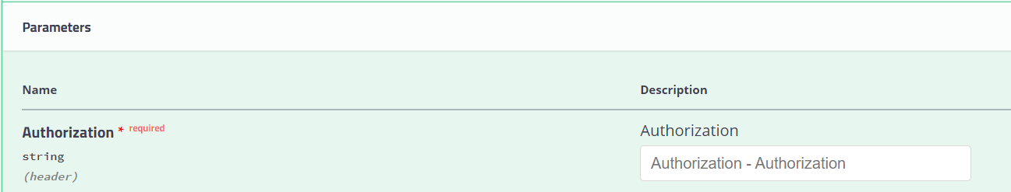

Order Details as like below structure (JSON Provided)
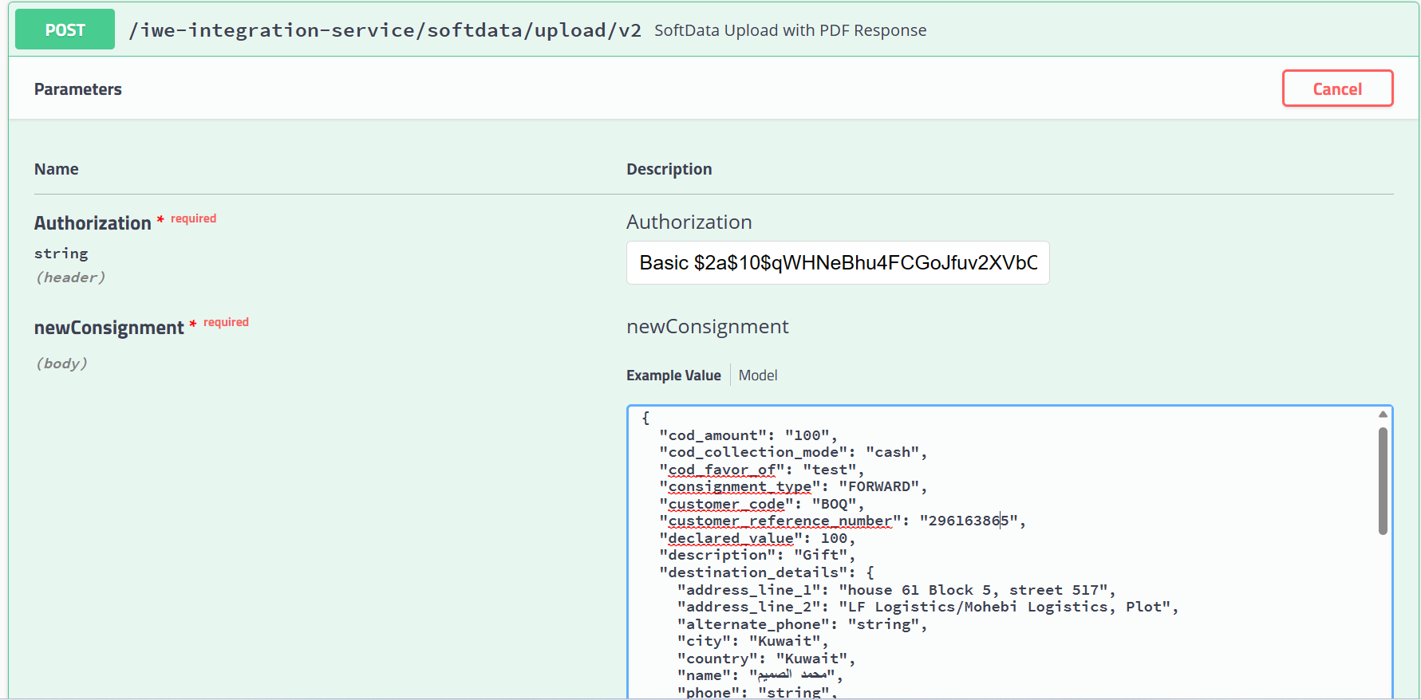
Request JSON
{
"cod_amount": "string",
"cod_collection_mode": "string",
"cod_favor_of": "string",
"consignment_type": "string",
"customer_code": "BOQ",
"customer_reference_number": " 296163865",
"declared_value": 0,
"description": "string",
"destination_details": {
"address_line_1": "string",
"address_line_2": "string",
"alternate_phone": "string",
"city": "string",
"country": "string",
"name": "string",
"phone": "string",
"pincode": "string",
"state": "string"
},
"dimension_unit": "string",
"height": "string",
"is_risk_surcharge_applicable": true,
"length": "string",
"load_type": "string",
"notes": "string",
"num_pieces": 0,
"origin_details": {
"address_line_1": "string",
"address_line_2": "string",
"alternate_phone": "string",
"city": "string",
"country": "string",
"name": "string",
"phone": "string",
"pincode": "string",
"state": "string"
},
"pieces_detail": [
{
"declared_value": 0,
"description": "string",
"height": 0,
"length": 0,
"weight": 0,
"width": 0
}
],
"service_type_id": "string",
"weight": 0,
"weight_unit": "string",
"width": "string"
}

SAMPLE REQUEST
{
"cod_amount": "100",
"cod_collection_mode": "cash",
"cod_favor_of": "test",
"consignment_type": "FORWARD",
"customer_code": "BOQ",
"customer_reference_number": "296163865",
"declared_value": 100,
"description": "Gift",
"destination_details": {
"address_line_1": "house 61 Block 5, street 517",
"address_line_2": "LF Logistics/Mohebi Logistics, Plot",
"alternate_phone": "string",
"city": "Kuwait",
"country": "Kuwait",
"name": "محمد الصميم",
"phone": "string",
"pincode": "91710",
"state": "string"
},
"dimension_unit": "CM",
"height": "5",
"is_risk_surcharge_applicable": true,
"length": "10",
"load_type": "DOCUMENT",
"notes": "test",
"num_pieces": 10,
"origin_details": {
"address_line_1": "LF Logistics/Mohebi Logistics, Plot",
"address_line_2": "Mohebi Logistics; Plot WT01 & WT04",
"alternate_phone": "",
"city": "Dubai",
"country": "UAE",
"name": " مجموعة الكوخ",
"phone": "97101606811863",
"pincode": "8005",
"state": "DUBAI"
},
"pieces_detail": [
{
"declared_value": 100,
"description": "Gift",
"height": 100,
"length": 500,
"weight": 1.2,
"width": 200
}
],
"service_type_id": "PREMIUM",
"weight": 1.2,
"weight_unit": "KG",
"width": "200"
}

Response JSON: [PDF Stream response]
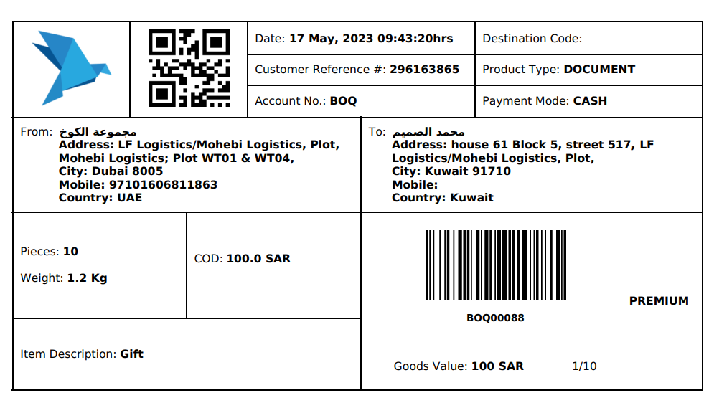

API #2: Consignment Tracking

API URL:
http://15.207.62.25:5001/iwexpress/iwe-integration-service/tracking/{referenceNumber}/shipment
Request Type : GET
Authorization:
Basic $2a$10$qWHNeBhu4FCGoJfuv2XVbO9Yq4QBUwGSvNM0bGpYUVc3iY8jXsJwO
referenceNumber:
[consignment reference number]
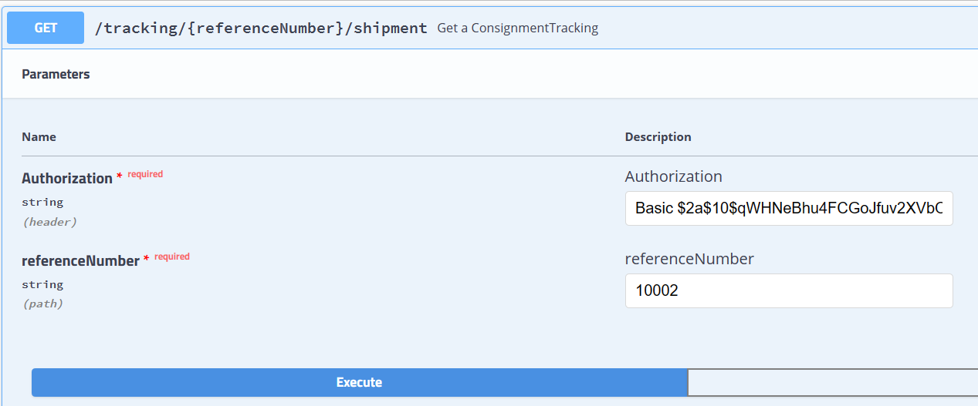

Sample Request:
http://15.207.62.25:5001/iwexpress/tracking/10002/shipment
Response JSON: [Consignment Tracking details]

Client Status Update Webhook

Following are the list of events (with description) supported which is provided in the key type as seen in the payload.
Supported Events
- on_hold
- release_on_hold
- pickup_completed
- delivered
- attempted
- rto
- cancel
- handover_courier_partner
- intransit_to_hub
- reached_at_hub
- inscan_at_hub
- out_for_pickup

